Covid Ripple Effect! No Place to Go.

by

Michael Argentieri

Bars & restaurants are not the only businesses that are suffering due to

Covid-19 pandemic restrictions. Many small businesses such as limousine

companies, hair salons & musicians, to name a few, rely heavily on the success of

bars and restaurants to make their bottom line.

As Donny Zoladz of Zoladz Executive Transportation in Depew says,

“People got no place to go.” Zoladz, who has been in business since 1987’,

had to, once again, temporarily shut down his business last December and

Remains closed. With an $8000. per month insurance bill alone it just was not

feasible to remain open with bars and restaurants being so limited by numerous

[restrictions.](https://www.governor.ny.gov/news/governor-cuomo-announces-restaurants-bars-other-sla-licensed-entities-must-close-person-service)

In a normal year Zoladz has had as many as 20 part time drivers and a

support staff of up to five. In 2020, during the approximately six months that he

could be open, his staff was made up of 9 drivers, his office manager and

himself. The bar/restaurant [wedding] clientele make up over 80% of his business.

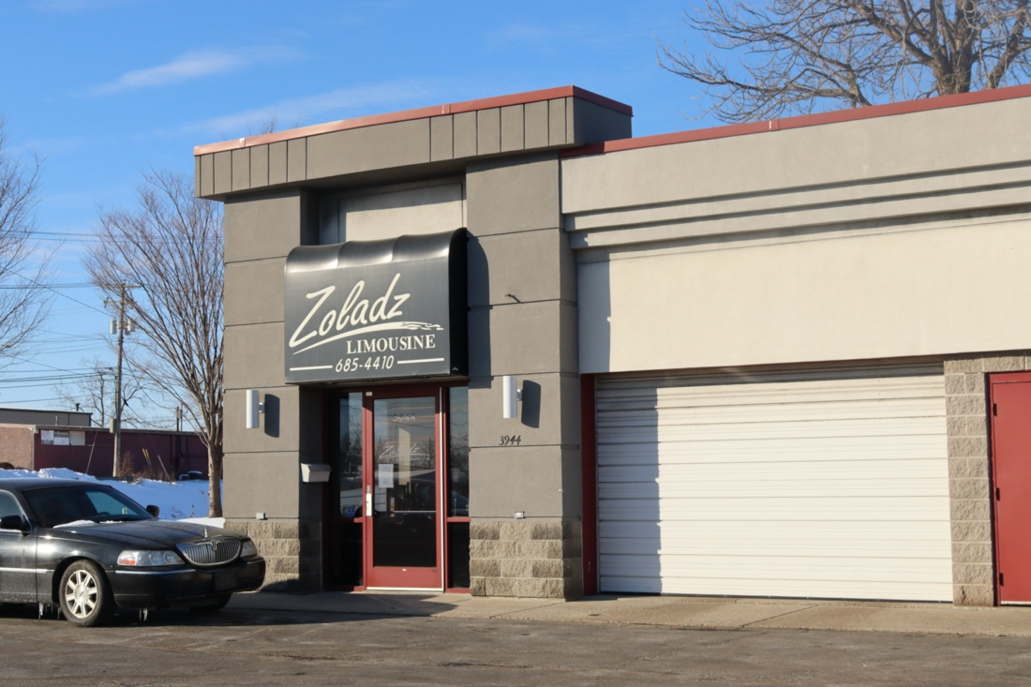

Temporarily closed.

Zoladz is optimistic though, he has weathered the storm and is looking for a

big upsurge in business in the late spring and over the summer. When asked

what he thought about Gov. Cuomo and his handling of the pandemic? Zoladz

responded with “I don’t much care either way with most politicians, but I hate

Cuomo”.

Right down the road in Depew from Zoladz is The Salon & Spa

which closed for good, after nearly 16 years at that location, last April.

Owner/operator Gina Dagastino, says “I’m done.” Dagastino, who has owned her

own salon since the late 80’s, has now become an Independent contractor by

Subletting space or “renting a chair” and working out of a friend's salon.

Dagastino says, “Having to give up my own place of business after 28 years

was heartbreaking.” She went on to say, “I busted my butt for 28 years in

NY state following strict health dept., guidelines and paying taxes to build a

business and here comes Cuomo telling me I must close, but thousands of

people can go to Walmart or Home Depot.” “It's not fair and it’s not safe. What,

Covid doesn’t go to Walmart?”

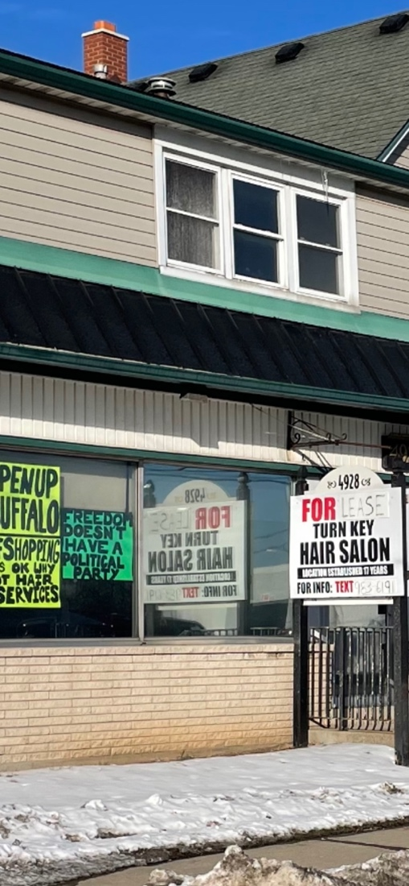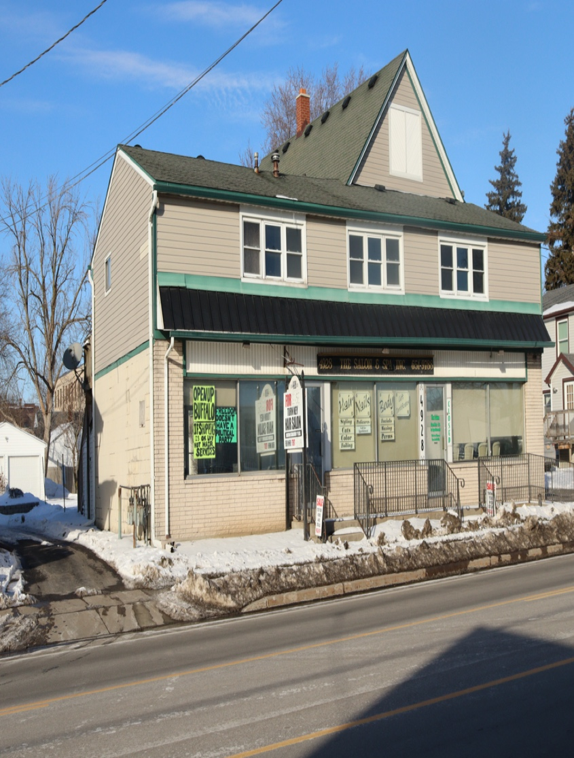

Closed for good.

Dagastino was really upset with the fact that the Governor is telling her that

she cannot earn a living, but he is not telling people they don’t have to pay N.Y.

taxes. Even when hair salons could reopen, she was and still is working for half of

what she normally earns. With all the restrictions put on [hair salons](https://www.governor.ny.gov/sites/governor.ny.gov/files/atoms/files/HairSalonsAndBarbershopSummaryGuidance.pdf) juxtaposed by

the restrictions put on bars/restaurants which in turn has caused so many people to

be out of work. People are not bothering to go out and are opting to save money

on their hair. When I asked what she thought of Gov. Cuomo, Ms. Dagastino

launched into an intemperate diatribe that I cannot print.

Buffalo Music Hall of Fame musician Michael Hund says, “musicians

were left out in the cold” by Gov. Cuomo. Live music venues not only had to

comply with the strict bar/restaurant restrictions, the NY State Liquor

Authority also decreed that venues could not have ticketed or advertised shows,

only ‘incidental music’ in bars/restaurants.” So, Hund made a federal case out of

it by filing a [lawsuit](https://buffalonews.com/news/local/musician-wins-early-rulings-in-lawsuit-against-cuomos-ban-on-live-performances/article_cd006b4a-281c-11eb-8e86-8bd5217d8dad.html) last August in Federal Court. On Nov. 16,2020, Judge John

L. Sinatra Jr. Struck down the SLA rule as “Arbitrary.”

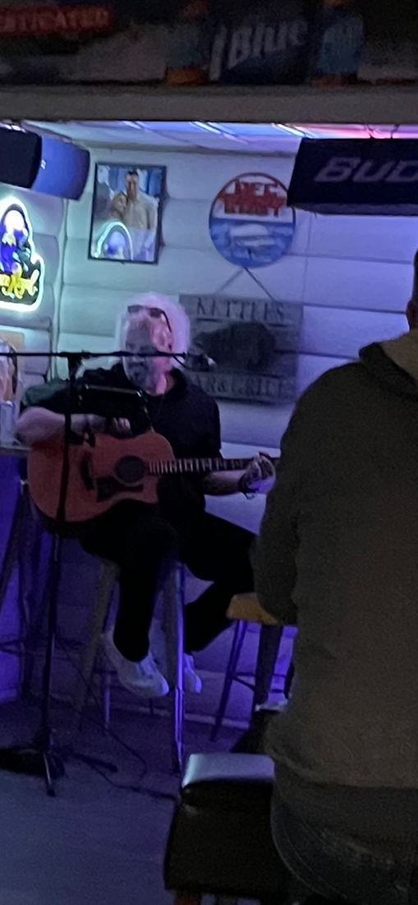

Michael Hund at “Kettle’s” of Orchard Park, singing the Blues, literally

Ample rules have been put in place by the state with regards to Covid-19 for

good reason. However, people are following mask & social distancing

guidelines, vaccines are coming available, and it seems the worst is behind us.

People need to earn a living and need to be able to pay their bills.

It seems that every time we take one step forward to getting back to

normal, we then take two steps back. On Feb. 11th NY State stated that

professional sporting events can now allow 10% capacity. But, also on Feb. 11th,

2021, an appellate court Judge of the Fourth Department overturned last week's

Supreme Court Ruling that allowed bar/restaurants to be open past 10pm to

midnight. On Feb. 12th Gov. Cuomo changed the curfew to 11pm. Dry

cleaners, florist, vendors that provide services to bars/restaurants, etc., are all

feeling the pinch or the “ripple effect” of the Covid-19 restrictions.